Evolution by Howard Ratcliffe

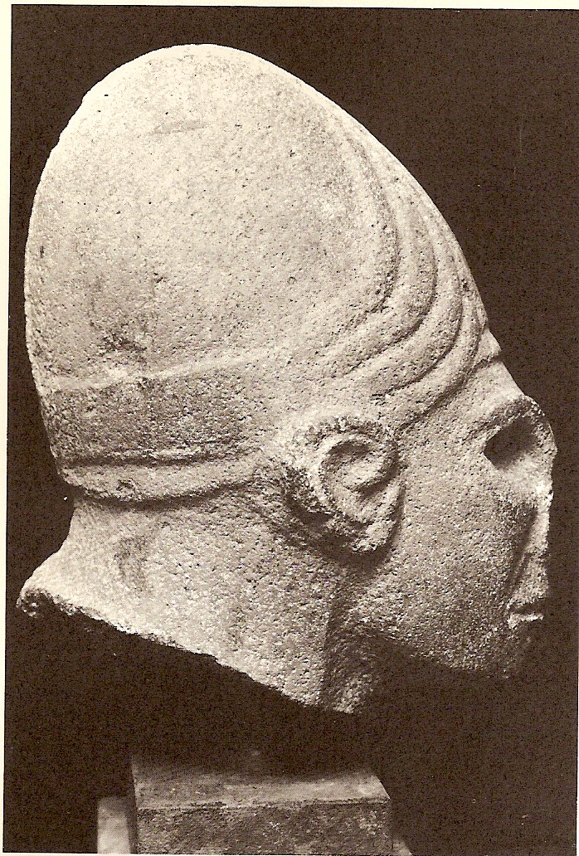

Who’s your daddy?

The Phoenician “Father of Men” was called “El”. Star of the movie, Planet of the Apes, by around 1400 BC he was depicted with a sloping forehead, heavy wrinkled skin, barrel chest, wearing a leather helmet. Phoenicians sailed to the Americas at least 2000 years before Columbus had donned his Red Templar Cross outfitted ship named after the goddess (Santa Maria) or Leif Eriksen had raped and pillaged his way around the Atlantic in his famous horned hat, so it’s not unusual the Maya began to shape their Royal children’s heads into this shape at birth in honor of the corn goddess, Ceres. For the Phoenicians, El’s son Uranus, the sky-god married his twin sister Gaea, the earth-goddess, and today their religion is the fastest growing religion of all time by far. According to some scientists (the ones who can’t read the basic photosynthesis equation) she is having a severe hot flash caused from too many humans using up her resources, but who is she really? Greeks taught the voluptuous goddess Gaea and the deep dark god Chaos produced the universe. Egyptians taught that the Orphic Egg of Horus (son of a similar union of twin brother and sister; Isis and Osiris) fell into the Nile to spontaneously produce the world. This ridiculous notion is not at all unlike today’s scientists (the ones who ignore the impossibility in the creation of energy and matter as well as basic laws of thermodynamics) today say a primordial Black Hole exploded and formed the universe. At the end of Paul’s 1st letter to Timothy, he warns him to beware of science which is “falsely so called”; maybe we should heed his advice!
Basic laws of thermodynamics state that randomness “Entropy” increases over time leading to more Chaos. This opposes evolution theory which says that less complicated organisms evolved into more complicated animals and eventually into human beings with souls, spirits, a conscience and altruistic tendencies. Evolution theory says the egg developed into a chicken. Creation theory, whether Chaos and Gaea did it, or God did it alone say the chicken was created to create the egg, so which theory is correct?
In a nutshell (another conundrum), evolution theory says the universe began chaotically with the “Big Bang”, an explosion of a primordial “Black Hole” containing all matter in the universe. As extreme temperatures began to cool, small particles called quarks formed, and then as energy levels continued to decrease, quarks combined to form protons, neutrons and electrons which then combined to form atoms and finally molecules of different sizes called elements. Problem: Hydrogen and Helium might be created under this theory, as observed in the nuclear reaction of stars, but anything heavier would require a different method of production, and all this has been proven by enormously expensive particle accelerators. As Big Bang theory progresses, an attractive force called “Gravity” begins to slow the expanding particles of matter down, and collect them into stars and planets. Problem: This force has not been proven to exist, and the universe is still said to be expanding, not contracting. Planets then begin to orbit stars, but why they would become spherical is not understood or explainable by the Big Bang theory and the earth happens to have water and an orbital distance from its sun which keeps water in liquid form from evaporating too fast or freezing. How the water made its way here through space is another good question. Carbon molecules combine with 100 other elements and form DNA strands which make a trillion connections over and over in a million different ways to form the first single celled living organism. These organisms become specialized, and symbiotically combine to form ever more complicated organisms. Plants form and begin to use the water and carbon from their own decomposing bodies to form oxygen (an impossible feat) needed for fish and animals to live. Fish fins become bird wings, then monkey arms and finally human arms. Problem: Species with these transitional appendages in both male and female would need to form simultaneously, and none have been observed in the fossil record. Humans develop and soon possess a sense of right and wrong, a reverence for their creator, a spirit to communicate with this creator and the sense that their soul may not pass judgment. The odds of this happening by chance are about as likely as you winning the Lottery every time you purchase a ticket.
Evolution theory denies the influence of a Creator. In essence, this is Blasphemy of the Holy Ghost which results in God giving them over to a Reprobate Mind (ref Rom 1). Evolution requires increased order and therefore not only an energy source, but a very intelligent one at that. It simply is impossible for this increased order to evolve out of chaos within the universe naturally. Thermodynamics is essentially a study of this chaos or randomness. Laws state it takes energy to create order out of chaos, so where does the energy come from? Heat is a measure of the movement of molecules, and in a closed system, it is always observed as becoming colder, slower moving and more ordered, the exact opposite of evolution theory. On the surface, Evolution theory sounds like it denies the influence of a Creator, but ironically it is a theory which requires a source of outside energy for it to be considered, so maybe its creator is there but just hiding. Nobody seems willing to admit they worship Satan, but if not God, it must be Satan, right? Phoenicians proposed a monkey looking god-man called “El” created man, and Charles Darwin proposed that monkeys became man. To me, it looks like his theory just evolved from the Phoenicians!
The natural outcome of “Survival of the Fittest” is the death of everyone else. Wars use human cannon fodder to cull the less desirable of humanity from each side while enriching the most highly evolved. At some point, according to the highly evolved Buddhist god man, the Dalai Lama will be World Peace, so the days of cannon fodder will be over; weapons will be in the hands of the most highly evolved and save for a few million slaves, the Utopia envisioned by Karl Marx will be achieved.

